Managing certificates and the Java KeyStore (JKS) is crucial for ensuring secure communication in Java-based applications. Here's a detailed explanation of certificates handling and the JKS.

1. What is a Certificate?
A certificate is a digital document that verifies the ownership of a public key. It is issued by a trusted entity, called a Certificate Authority (CA). Certificates are used in SSL/TLS to establish secure communication.
Key Components of a Certificate:
- Subject: Identifies the entity the certificate is issued to.
- Issuer: The CA that issued the certificate.
- Public Key: Used in encryption and digital signature verification.
- Validity Period: Start and end date of the certificate's validity.
- Signature: Digital signature of the CA to ensure authenticity.

2. What is a Java KeyStore (JKS)?
A Java KeyStore is a repository used to store certificates and private keys securely. It is a file-based storage that Java applications use for encryption, authentication, and secure communication.
- KeyStore Types:
  - JKS: Java's proprietary keystore format.
  - PKCS12: A standard keystore format supported by Java.
Common Use Cases:
- Store private keys and their corresponding certificates.
- Store trusted certificates (e.g., CA certificates) for verifying peers.

3. Managing Certificates with JKS

Creating a JKS
To create a new JKS, use the keytool command:
keytool -genkeypair -alias mykey -keyalg RSA -keystore mykeystore.jks -keysize 2048
- -genkeypair: Generates a key pair (private and public key).
- -alias: A unique name for the key entry.
- -keystore: Specifies the JKS file.
- -keysize: Length of the RSA key.

Importing a Certificate into JKS
If you have a CA-signed certificate, you can import it into a JKS.
- Import the CA Certificate:
keytool -import -trustcacerts -alias rootca -file rootca.crt -keystore mykeystore.jks
- Import the Signed Certificate: After the private key's certificate signing request (CSR) is signed by a CA:
keytool -import -trustcacerts -alias mykey -file mycert.crt -keystore mykeystore.jks

Exporting a Certificate from JKS
To share a public certificate:
keytool -export -alias mykey -file mycert.crt -keystore mykeystore.jks

Listing Entries in JKS
To view the contents of a JKS:
keytool -list -keystore mykeystore.jks

Generating a Certificate Signing Request (CSR)
A CSR is sent to a CA to request a signed certificate:
keytool -certreq -alias mykey -file myrequest.csr -keystore mykeystore.jks

Changing the Password of a JKS
To update the JKS password:
keytool -storepasswd -new newpassword -keystore mykeystore.jks

4. Using JKS in Java

Loading a JKS
Java applications can use the KeyStore API to load and interact with a JKS:
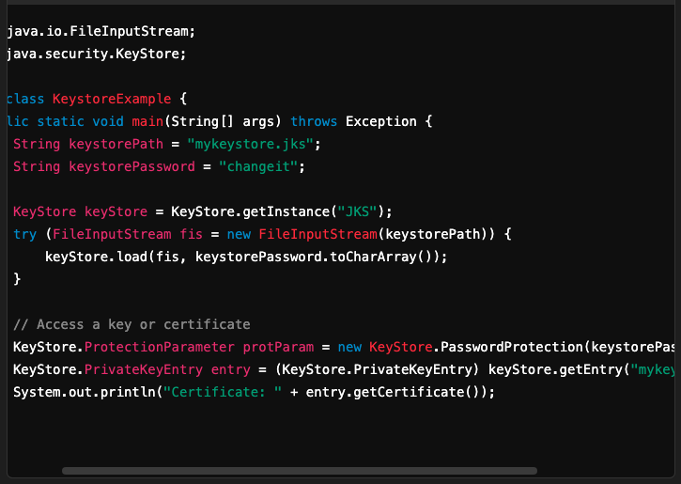

Configuring SSL in Java Using JKS
To enable SSL in a Java application (e.g., HTTP server), configure the keystore:
- Set System Properties:
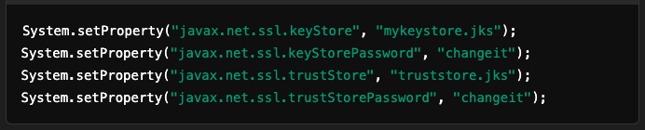
- Use an SSLContext:
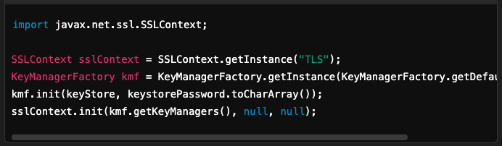

5. Security Best Practices
- Strong Passwords:
  - Use strong passwords for keystores and key entries.
- Limit Access:
  - Restrict access to the keystore file to authorized users only.
- Rotate Certificates:
  - Renew and rotate certificates before expiration.
- Backup Keystores:
  - Maintain secure backups of keystores to prevent data loss.
- Use PKCS12:
  - Prefer PKCS12 over JKS as it is more secure and interoperable.
- Encrypt Private Keys:
  - Always protect private keys in the keystore with a password.

6. Common Tools for Certificate Management
- OpenSSL: General-purpose cryptography toolkit for certificates.
- Keytool: Java's built-in utility for managing keystores.
- Certbot: Tool for obtaining free SSL/TLS certificates from Let's Encrypt.

This covers the essentials of certificates handling and JKS in Java applications.

